
A
PROJECT REPORT

ON

“Flight Price Prediction”
SUBMITTED

TO

SAVITRIBAI PHULE PUNE UNIVERSITY, PUNE
FOR THE AWARD OF

MASTER IN COMPUTER APPLICATION
(MCA-II, SEM-III)

SUBMITTED BY

Shubham Soni

UNDER THE GUIDANCE OF

Dr. Rajesh Gawali

SINHGAD INSTITUTE OF MANAGEMENT AND COMPUTER
APPLICATION, PUNE
A.Y. 2022-23

 | SINHGAD TECHNICAL EDUCATION SOCIETY’S  SINHGAD INSTITUTE OF  MANAGEMENT & COMPUTER APPLICATION  (Affiliated to Savitribai Phule Pune University & Appoved by AICTE)  ‘NAAC’ Accredited with ‘A’ Grade |  |  | 
S. No. 49/1, Off Westernly Bypass, Pune – Mumbai Expressway, Narhe, Pune – 411041, Tel : (020) 66831896 / 66831908 / 66831907
E-mail : director_mca_simca@sinhgad.edu Website : www.sinhgad.edu

Prof. M. N. Navale  M.E. (Elec), MIE, MBA  FOUNDER PRESIDENT |  | Dr. (Mrs.) Sunanda M. Navale  B.A., P.P.M., Ph.D.  FOUNDER SECRETARY | Dr. Vijaya Puranik  M.Sc., MMM,MPM, Ph.D.  DIRECTOR, SIMCA

CERTIFICATE OF THE GUIDE

This is to certify that the project entitled “Flight Price Prediction” which is being submitted herewith for the award of the partial degree of Master of Computer Application (MCA) to Savitribai Phule Pune University, Pune is the result of the original research work completed by Shubham Soni under my supervision and guidance and to the best of my knowledge and belief the work embodied in this project has not formed earlier the basis for the award of any Degree or similar title of this or any other university or examining body

Place: Pune
Date:

Dr. Rajesh Gawali Dr. Rajesh Gawali Dr. Vijaya Puranik
Internal Guide Academic Head & Director SIMCA-MCA
Project Co-ordinator

External Examiner

i
DECLARATION

I, the undersigned hereby declare that the project titled “Flight Price Prediction”, being submitted for the award of degree of Master of Computer Application by me to Sinhgad Institute of Management and Computer Application (SIMCA)
affiliated to Savitribai Phule Pune University is the result of an independent
work carried out under the guidance of Dr. Rajesh Gawali, is my original work.
Further I declare that this project has not been submitted to this or any Institution
for the award of any degree.

PLACE: PUNE Shubham Soni
DATE: (Student)

ii
ACKNOWLEDGEMENT

I would like to thank all those people who have direct and indirect contributions in the completion of this thesis. First of all, I would like to thank my research guide Dr. Rajesh Gawali amd Dr. Poonam Sawant, for his esteemed guidance, support and encouragement to work on whatever problems motivated me.
My sincere gratitude goes to , Research Head and Director, Sinhgad Institute of Management and Computer Application (SIMCA)-MCA, Pune. His continuous moral support and motivation in every research phase helped me to complete this work.
I would also like to thanks my wonderful colleagues and friends of Sinhgad Institute of Management and Computer Application (SIMCA), Pune, Dr. Rajesh Gawali, and Dr. Poonam Sawant and my friend Rohit Guhmare for their timely help, cooperation and fruitful discussion. My thanks are due to all non-teaching staff of SIMCA, Pune.
Last but not least, I would like to thanks all my students for their best wishes. Above all I am grateful to the almighty lord Ganesha, lord Shiva and Sai baba, by the grace of whom this thesis is completed.

Shubham Soni

iii
PREFACE
With the advent of the aviation travel industry, a large number of datamining technologies have been developed to increase profits for airlines in the past two decades. The implementation of the digital optimization strategy leads to price discrimination, for example, similar seats on the same flight are purchased at different prices, depending on the time of purchase, the supplier, and so on. Price fluctuations make the prediction of ticket prices have application value. In this paper, Random forest algorithm is proposed to predict the price of an air ticket. The experimental results show that the model is more reliable by comparing the forecasting results with the actual results of each price model. The model is helpful for passengers to buy tickets and to save money.
Optimal timing for airline ticket purchasing from the consumer’s perspective is challenging principally because buyers have insufficient information for reasoning about future price movements. In this project we majorly targeted to uncover underlying trends of flight prices in India using historical data and also to suggest the best time to buy a flight ticket.
For this project, we have collected data from 18 routes across India while the data of 4 routes were extensively used for the analysis due to the sheer volume of data collected over 4 months resulting in 5.28 lakh data points each across the Mumbai-Delhi and Delhi-Mumbai route and 1.05 lakh data points each across the Delhi-Guwahati and Guwahati-Delhi route. The project implements the validations or contradictions towards myths regarding the airline industry, a comparison study among various models in predicting the optimal time to buy the flight ticket and the amount that can be saved if done so. A customized model which included a combination of ensemble and statistical models have been implemented with a best accuracy of above 90% for a few routes, mostly from Tier 2 to metro cities. These models have led to significant savings and produced average positive savings on each transaction
For data pre-processing and analysis she has selected pig scripting language on the top of MapReduce and built predictive analytics using machine learning techniques. This System reduces error rate and gives correct prediction. Finally, researcher has suggested an effective solution for the farmer industry.

iv
Keywords
- Machine learning
- Linear Regression
- Decison Tree
- Random Forest
- Nueral MultiLayer Perceptron(ReLu)
- k-nearest neighbor
- Comparing Models
- Data sets
- Crop
- Treat Null Values
- Data Information
- Visualization

v

CONTENTS

Chapter | Title | Page No.
 | Certificate | i
 | Declaration | ii
 | Acknowledgement | iii
 | Preface | iv
 | Keywords | v
 | Contents | vi
1 | Introduction | 1
2 | Review of Literature | 8
3 | Large Scale Data Analytics Framework | 18
4 | Flight Price Prediction and Analysis | 22
5 | Machine Learning Algorithm Used | 29
6 | Conclusion | 33
7 | Bibliography | 33

vi
Chapter 1
Introduction

  - Introduction
Since the airline company's privatization, the airfare pricing scheme has evolved into a complex framework of sophisticated regulations including numerical simulations that determine airfare marketing strategies. Even though these principles are still mostly unknown, research has revealed that they are influenced by a range of circumstances. Conventional characteristics such as distance, while still important, are no longer the only determinants of pricing structure. Economic, marketing, and sociological factors have all played a growing influence in determining flight pricing.
The majority of research on airfare forecasting has concentrated either on state scale or a single market. However, analysis at the business segment level is still relatively scarce. The marketing strategy is defined as the market/airport pairing in between aircraft sender and receiver.
The tourism industry is changing fast and this is attracting a lot more travelers each year. The airline industry is considered as one of the most sophisticated industries in using complex pricing strategies. Now-a-days flight prices are quite unpredictable. The ticket prices change frequently. Customers are seeking to get the lowest price for their ticket, while airline companies are trying to keep their overall revenue as high as possible. Using technology it is actually possible to reduce the uncertainty of flight prices. So here we will be predicting the flight prices using efficient machine learning techniques

  - Motivation
Motivation is to help people who use flight in regularly and some time so people find flight and show very high price to the customer so my motivation is take flight ticket in low price so I use data for prediction the ticket price.

  - Justification of the Problem
Flight ticket prices can be something hard to guess. we have been provided with prices of flight tickets for various airlines between the months of March and June of 2022 and between various cities, using which we aim to build a model which predicts the prices of the flights using various input features. So you find the solution of high ticket price.

  - Objectives of the Study
The researcher has set the following main objectives of the study.
- To study the need of Airline services.
- Use of various ML methods to know more about dataset and get accurate results.
- To get effective Flight Ticket price for the customers.

  - Hypothesis
H1 Weeding Season time effect of Flight Price.
H2 Rainfall is impact on Flight.
H3 at the time of summer vacation price effect.

  - Research Methodology
It is critical for airlines to be capable of predicting airfare trends at the market segment level in order to alter strategies and resources for a given route. Scientific literatures on business segment price prediction, on the other hand, use biased conventional predictive methods, including such linear regression [6] [7], and thus are founded on the supposition that the selected variables have a linear relationship, that might not be true in most cases. Proposed research [8] Prediction of airfare prices utilizing machine learning approach, A dataset of 1814 Aegean Airways data flights was gathered and utilized to develop the machine learning technique for the study effort. Various figures of variables have been used to train the classifiers to demonstrate how feature extraction might affect validity of the model.
A study by William Groves' [9] shows that an operator can be introduced who can maximize purchase time on behalf of consumers. A model is constructed using the partial least squares approach..
fare forecasting using machine learning models employs a tiny dataset consisting of flights between Delhi and Bombay.

1.1 Flow of the model

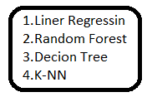
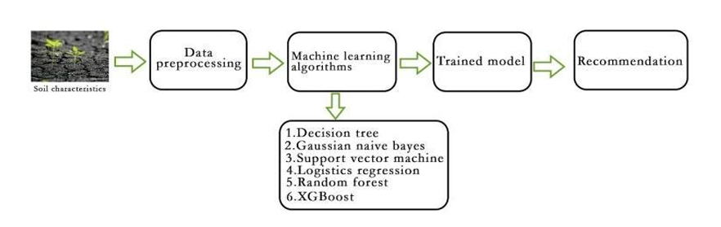
    - Sampling
According to survey and information from
- Airline
- Flight
- departure_time
- source_city
- destination_city

    - Data Collection
The important a part of the project is data collection. Data on different websites is gathered with unique attribute to provide the best accuracy. The data is collected from website kaggle.com and www.dgca.in and the models are implemented using python. The python-script helps to easily pre-process the data and forecast the output. The duplicate values are avoided in the pre-processing step. This dataset is more concentrated on calculating the plane price value. The dataset contains the data with attributes such as.
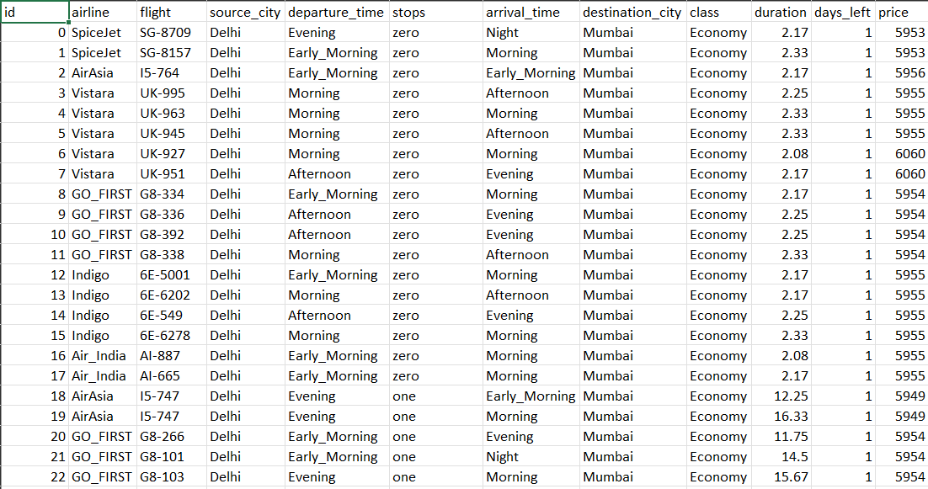
Table 1.1 Data set
  - Limitations of the Study
Following are the limitations of the study.
- The present study is limited to analyze and predict Price.
- The study is confined to analyze only multi structure data not images, videos etc.
- Only classification machine learning algorithms are used to build predictive model.

  - Thesis Outline
The thesis entitled “ Flight Price Prediction” comprises of seven chapters described as follows
Chapter 1: Introduction
Since the airline company's privatization, the airfare pricing scheme has evolved into a complex framework of sophisticated regulations including numerical simulations that determine airfare marketing strategies. Even though these principles are still mostly unknown, research has revealed that they are influenced by a range of circumstances. Conventional characteristics such as distance, while still important, are no longer the only determinants of pricing structure. Economic, marketing, and sociological factors have all played a growing influence in determining flight pricing.
The majority of research on airfare forecasting has concentrated either on state scale or a single market. However, analysis at the business segment level is still relatively scarce. The marketing strategy is defined as the market/airport pairing in between aircraft sender and receiver.

Chapter 2: Literature Review
To solve the problem of High Price of Flight so we Choose this project for solving the problem of high price and who use flight in regularly and some time so people find flight and show very high price to the customer so my motivation is take flight ticket in low price so I use data for prediction the ticket price.

Chapter 3: Data Collection
The collection of data is the most important aspect of this project. There are various sources of the data on different websites which are used to train the models. Websites give information about the multiple routes, times, airlines and fare. Various sources from APIs to consumer travel websites are available for data scraping. In this section details of the various sources and parameters that are collected are discussed.

Chapter 4: MACHINE LEARNING ALGORITHM
To develop the model for the crop prediction, many conventional machine learning algorithms are evaluated. They are as follows: Linear regression, Decision tree, Random Forest Algorithm, K-Nearest neighbors, Multilayer Perceptron, Support Vector Machine (SVM) and Gradient Boosting. All these models are implemented in the scikit learn. To evaluate the performance of this model, certain parameters are considered. They are as follows: R-squared value, Mean Absolute Error (MAE) and Mean Squared Error (MSE).
Chapter 5: PREDICTORS
After evaluating the performance of the all machine learning models, further improvements are made using a correct predictor model for the best result. Two separated train models are developed by applying the trained datasets. Also the appropriate weights are assigned to them to get a better predictor model
Chapter 6: Conclusion
According to the literature survey done, we propose a novel approach through machine learning with parallel computation to solve the problem of more complex computation to predict the optimized solution considering selective parameters. Further we try to extend and complete the loop by using prescriptive analysis to give complete prescription to the farmer for necessary action and automatize the complete process.

  - References
- chrome-extension://efaidnbmnnnibpcajpcglclefindmkaj/http://shodh.inflibnet.ac.in:8080/jspui/bitstream/123456789/7328/3/03_literature%20review.pdf
- https://www.researchgate.net/publication/340594772_CROP_YIELD_PREDICTION_USING_MACHINE_LEARNING
- W. Groves and M. Gini, An agent for optimizing airline ticket purchasing, 12th International Conference on Autonomous Agents and Multiagent Systems (AAMAS 2013), St. Paul, MN, May 06 – 10, 2013 , pp. 1341-1342.

- T. Janssen, A linear quantile mixed regression model for prediction of airline ticket prices, Bachelor Thesis, Radboud University, 2014.

Chapter 2
Literature Review

2.1 Introduction
Machine learning is an emerging research field in flight price analysis. Any individual who has booked a flight ticket previously knows how dynamically costs change. Aircraft uses advanced strategies called Revenue Management to execute a distinctive valuing strategy [1]. The least expensive accessible ticket changes over a period the cost of a ticket might be high or low. This valuing method naturally modifies the toll as per the time like morning, afternoon or night. Cost may likewise change with the seasons like winter, summer and celebration seasons. The extreme goal of the carrier is to build its income yet on the opposite side purchaser is searching at the least expensive cost. Purchasers generally endeavor to purchase the ticket in advance to the takeoff day. Since they trust that airfare will be most likely high when the date of buying a ticket is closer to the takeoff date, yet it is not generally true. Purchaser may finish up with the paying more than they ought to for a similar seat.
A report says India’s affable aeronautics industry is on a highdevelopment movement. India is the third-biggest avionics showcase in 2020 and the biggest by 2030. Indian air traffic is normal to cross the quantity of 100 million travelers by 2017, whereas there were just 81 million passengers in 2015. Agreeing to Google, the expression ”Cheap Air Tickets” is most sought in India. At the point when the white collar class of India is presented to air travel, buyers searching at modest costs. The rate of flight tickets at the least cost is continuously expanding
- Crop recommendation for farmers with different location.
- Traditional Analytical and Prediction Systems.
- Big Data Analytics for Prediction and Behavior Analysis in crop and fertilizers.

2.2 Fight Recommendation of another Company.
Nowadays more and more research is going in the field of Airline domain. Identify what is the challenge in Indian Airline and come up with new solutions to help Customer. The paper, and mainly throw light on the recommendation of the crop which crop to grow according to your soil nutrition value and weather condition. In this paper, the author starts from the very basics of smart booking and slowly moves towards developing a model which will help the Customer to grow suitable to the along with the weather conditions. The Machine Learning algorithm used for crop recommendation in this paper is Decision tree, KNN, Linear Regression, ensembles. The conclusion is that the ensembles model is the best suitable for the crop recommendation model. In the “Improved Segmentation Approach for flight price expeccted” paper [4] the author uses 82.00274423 80.31964408 82.327629 80.15836264 81.60487287 83.37011772 82.63941394 8289408619 83.5352163 6.50985292 7.038096361 7.840207144 6.980400905 7.628472891 7.073453503 5.70080568 5.718627178 6.685346424 202.9355362 226.6555374 263.9642476 242.8640342 262.7173405 251.0549998 271.3248604 241.9741949 230.4462359 Airindia, Indigo, the approach in which he tried different-different machine learning models based on the The performance matrix of the classification algorithm is compared based on accuracy and execution time. “Diseases Detection of Various Flight Price Using Linear and random Forest Processing Techniques: A Review” paper [3] presents a vivid representation of Seats Availability detection using different-different techniques and tries to enhance the Seat. The author has tried to solve this issue by using the neural network state of the technique.

  - Traditional Analytical Systems for prediction of price

The dataset used in our project is provided by Professor Gini iv from University of Minnesota. It was originally collected using daily price quotes from a major travel search web site over the period February 22, 2011 to June 23, 2011. The data were used to build a regression model for computing expected future prices and reasoning about the risk of price changes. The data source contains information of seven different routes operated by several flight companies. The features selected to use in our model include: the departure week begin, weekday of the departure, price quote date, weekday of the price quote, number of days between fetch days and the departure, and the number of stops in the itinerary. To shed light on how the dataset looks like, Error! Reference source not found. shows a small portion of this dataset. It presents the trend of mean lowest price offered by all the airlines versus the number of days between fetchdays (purchase date) and the departure. To simplify the figure. 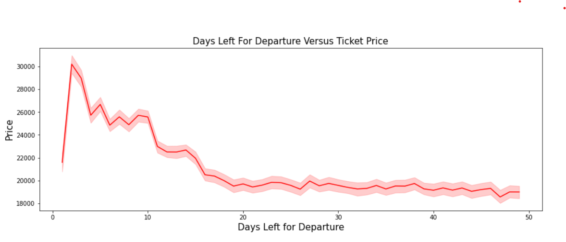

    - Relational Data Base Management Systems
In 1970 Database Management System (DBMS) was constructed using two approaches mainly hierarchical data model for storing enormous data generated by Apollo space program and network data model to create a standard database and resolve some of the difficulties of hierarchical model such as inability to represent complex relationships. But both models had disadvantages.
- For answering even simple query complex programs had to be written.
- Minimal data independency.

In early 1980’s Relational Database Management System (RDBMS) was developed for commercial use but unable to handle increasingly complex data. So later two new data models had emerged, the Object Relational Database Management Systems (ORDBMS) and Object-Oriented Database Management System (OODBMS) to implement the relational and object data models respectively to represent the third generation of Database Management System. The types of data generated by applications become richer than previous as the volume of data keeps growing. As a result, traditional relational databases are challenged to capture, store, search, transfer, analyse and visualize variety of bulky data. They focus on resolving the complexity of relationships among schema-enabled small amount of data only.

    - Data Mining Techniques and algorithms
Data Mining is the process of discovering patterns, trend and behavior using Machine Learning Algorithms, Artificial Intelligence and Statistics etc. The data mining process aims to extract valuable information from large dataset for future use. Data Mining is an essential step in predictive analytics and various data mining techniques and algorithms performs data mining and statistical analysis in order to determine trends and patterns in data. Data Mining Process involves Data Cleaning, Data Integration, Data Selection and Transformation, Data Mining, Pattern Evaluation and knowledge representation. Traditional database software based on SQL are not sufficient to discovering increased information Data mining technologies and techniques for recognizing and tracking pattern with in data helps business to know their customers. Many researchers have analyzed data and developed predictive models using data mining techniques, some of them we have briefed here.

IBM report” Predictive modeling techniques” focuses on predictive analytics techniques, including Predictive Model, Neural networks (NNs), clustering, support vector machines (SVMs), and association rulesto convert big data available today into real value. All these techniques identify hidden patterns from large data set of past data and resulting into a predictive model. Once predictive model is validated it is applied to a current situation to predict future [56][59].
The broadly used approaches and techniques are as follows.
- Regression Algorithms: Regression analysis is a statistical process for estimating the relationship among dependent and independent variables. [46]
- Association Algorithms: Association rules are if/then statements that help to uncover hidden relationships between unrelated data in a relational database or other information repository.[47]
- Classification Algorithms: Classification is a data mining function that assigns items in a collection to target categories or classes. [48]

- Clustering Algorithms: Clustering is a process which partitions a given data set into homogeneous groups based on given features [49]
- Artificial Neural Network Algorithms: Neural networks are computational structures consisting of an interconnected processing elements (PE) or nodes arranged on a multi-layered hierarchical architecture. [50]
Though many traditional data analysis methods efficiently handle structured data, still they can be utilized for big data analysis in the combination with big data technologies [75].

      - Prediction and Analysis using Machine Learning
Ruixuan Ren, Yunzhe Yang, Shenli Yuan in " Prediction of Airline Ticket Price" predict flight ticket mining to find out the positive and negative polarity of the student feedback based on pre-defined features of teaching and learning using supervised learning algorithms. They have developed an application of machine learning with the help of natural language processing techniques on student feedback data gathered from module evaluation survey results of Middle East College, Oman. They have analyzed data using Rapid Miner an open source data analytics tool and conducted comparative study of the algorithms like linear Regression, Random Forest, Decision Tree SVM, Naive Bayes, K Nearest Neighbor and Neural Network classifier to measure the performance. Depending on the results they found that, Neural Network gives the better performance followed by K Nearest Neighbor [27].
Dr. Janardhana and M Manjunath in ”Sentiment Analysis and Price Mining using Machine Learning Techniques”, elaborated that, a leading method for text message analysis is a sentiments or Flight analysis which gives the best results on opinions or sentiments. In this study, authors built the model and study the opinions associated with the movie review data in huge size. Movie reviews with labeled positive opinions are represented by 1 and negative opinions are represented by 0. The machine learning algorithms like Random Forest, Linear Regression, Decision Tree, K Nearest Neighbor are trained with 3,00,154 labeled data to forecast the opinion associated with unlabeled test data more precisely. This model helpful to determine the customer opinion associated with the unstructured data in digital format on web. The model is completely based on the NLP, Text Analysis, Machine Learning and Statistics [22].
In paper entitled “Prediction Ticket Price Using Machine Learning” authors R B Ravi Varma, Nagesh Y N, I M Umesh focused on Identifying the subjectivity and objectivity of information as the outcome of Sentiment Analysis which may be resulted in either positive or negative or a mix of both. According to authors, behavior identification is possible through sentiment analysis with machine learning. In recent days, opinion mining and sentiment analysis are being used to design innovative marketing strategies. Generated analog data is used to extract subjective contents and predict subjectivity such as positive or negative. This information is useful to build systems to understand customer’s demand and plan new business strategies accordingly. The chances of product failure can also be predicted using this. [36].

Figure 2.10 Spark implementation of sentiment analysis

Oscar Liombart in paper entitled “Using Machine Learning Techniques for Sentiment Analysis” [33]built test model and evaluate several machine learning methodslike Neural Network, Random Forest and Naive Baysfor the Sentiment Analysis task. The methodology he has used is shown in fig 2.11
Figure 2.11: Sentiment Analysis Model

According to him, a text classification problem is the type of text and the words that we can see in the data because it has an important impact on the number of words that the machine learning methods will learn and, in consequence, the final number of features. Using machine learning they have proved the effect of transformations on the data which can improve the performance of the classification methods but the type of transformations depends on the dataset and the language of the data. For text classification they found Neural Network as a best algorithm.
Wararat Songpan in the paper entitled “The Analysis and prediction of ticket price using Old data” proposed a probability's classifier model for analysis and prediction Despatch Time and arrival Time from our data set using Decision Tree and K nearest Neighbour as shown in figure 2.12. The classifier models used about Airindia and indigo in open comments for training data to classify comments as positive or negative called opinion mining. In addition, this classifier model has calculated probability that shows value of trend to give the rating using naive bayes techniques, which gives correctly classifier to 94.37% as compared with decision tree Techniques [34].
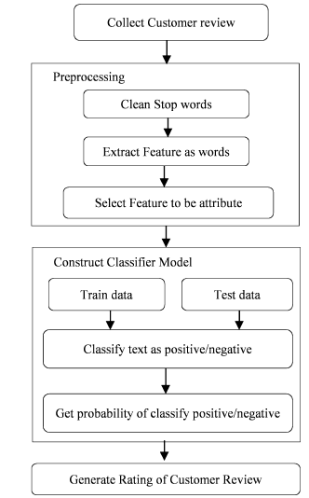
Figure 2.12: Probability classifier model
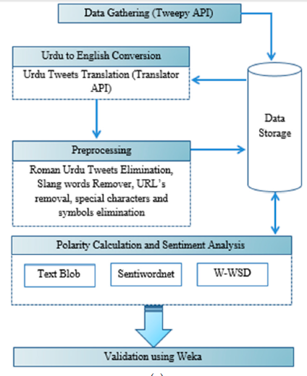
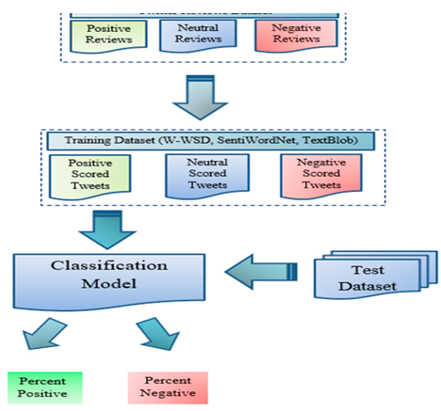
Figure 2.13. Tweet classification and sentiment analysis Framework;

Concluding Remark: Due to the digitization, Airline Company generates enormous amount of data from various data sources in variety. This data cannot be handling by traditional analytical tools due to their storage capacity and analytical ability but provides valuable insights. Big Data Analytics plays an important role in Airline industry to handle this data and provide upcoming trends. Researchers have suggested various big data technologies to develop big data analytics strategy. Many machine learning algorithms are used by the researchers to develop accurate predictive models but still more advancement is required for large amount of multi structured data.

  - REFERENCES
Research Papers:
- chrome-https://www.researchgate.net/publication/340594772_CROP_YIELD_PREDICTION_USING_MACHINE_LEARNING
- W. Groves and M. Gini, An agent for optimizing airline ticket purchasing,
- https://cs229.stanford.edu/proj2015/211_report.pdf

- T. Janssen, A linear quantile mixed regression model for prediction of airline ticket prices, Bachelor Thesis, Radboud University, 2014.

Chapter 3
Large Scale Data Analytics Framework

  - Introduction
Machine learning is an emerging research field in Flight Price analysis. Price prediction is a very important for gating Ticket in low Price. Any Customer is interested in knowing which Time Flight price is Low and how many days before buy ticket then gate ticket price is low. In the past, prediction was performed by considering Customer's experience on particular Flight. The Price is a major issue that remains to be solved based on available data. Machine learning techniques are the better choice for this purpose. Different Machine learning techniques are used and evaluated in Airline Industry for estimating the future productive Price production. This system is used to help To grow and select which flight is good and fast as per their Data set conditions and check the affected Price diseases and prevention. This is achieved by applying machine learning algorithms like Linear Regression and Random Forest and Decision tree on Given data and recommends suitable Flights for every particular Customer. The system focuses on creation of a prediction model which may be used for future prediction of Flight Ticket Price. It presents a brief analysis of Flight prediction using machine learning techniques.

  - Predictive Analytics
To analyze customer behavior and provide more personalized experience predictive analytics is a greater way. Predictive analytics is a stream of the advance analytics which make predictions about hidden future events from past occurrences. Predictive analytics is concerned with forecasting probabilities and trends. Predictive analytics involved Defining problem, Data collection, Data analysis, Statistics, Data Modeling and Deployment as shown in the figure 3.1. Predictive analytics plays an important role in prominence alongside the emergence of big data where enterprises store larger and broader pools of data in Hadoop clusters and other big data platforms. Therefore, predictive analysis can be done using big data technologies and Machine Learning Algorithms [1][2].

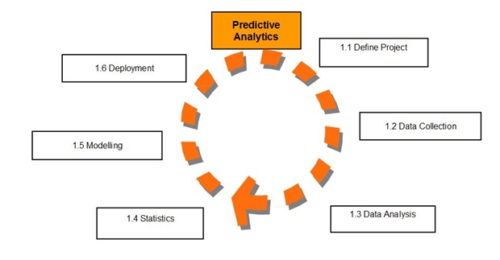
Figure 3.1: Predictive Analytics Process

  - Machine learning algorithms
Machine learning provides systems to automatically learn and improve the experience without programmed. It is an application of artificial intelligence (AI) that focuses on the development of computer programs which can access data for learning. It is categorized as supervised learning and unsupervised learning. Classification of Machine Learning Algorithms is shown in following diagram[10][11].

    - Supervised Learning
Machine learning uses supervised learning most frequently than unsupervised learning. In supervised learning we have input variables (x) and an output variable (Y) and an algorithm to learn the mapping function from the input to the output in such a way that if you have new input data(x) you can predict the output variables (Y).
Y = f(X)
It is called as supervised learning because the procedure of algorithm learning from the training dataset is similar to a learning process supervised by a teacher. Supervised learning problems can be further categorized into regression and classification problems. Some popular examples of supervised machine learning algorithms are; Naïve Bays, Neural Network, Linear Regression, Random Forest, Decision Tree and Support Vector machines [10].

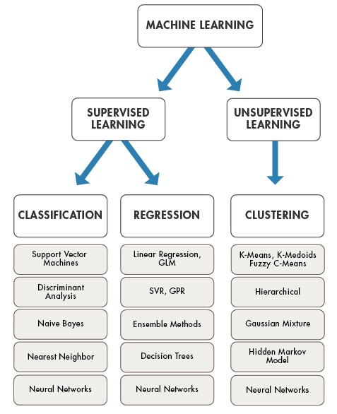
Figure 3.2: ML Algorithms
(Source https://www.mathworks.com/discovery/machine-learning.html)

    - Unsupervised Learning
Unsupervised learning does have only input data (X) and no corresponding output variables. The main aim of the unsupervised learning is to construct the model for the underlying structure or distribution in the data in order to know more about the data. In unsupervised learning there is no correct answers and supervision like teacher. Algorithms handles the things their own to discover the knowledge and present the interesting structure in the data. Unsupervised learning problems can be further divided into clustering and association problems. Mainly used algorithms are k-mean clustering and Apriori algorithm [10].
  - D3.js
Data visualization is very important task to present the data in a pictorial or graphical format. The main aim of the data visualization is to transfer the information clearly and efficiently using statistical graphics, plots and graphics etc. It is a JavaScript library used to create interactive and effective visualizations in the browser. Manipulation of elements of a webpage like HTML, SVG, or Canvas elements in the context of a data set is possible using D3.js library. DOM manipulation is also possible using this library. D3.js is a valuable utility in data exploration which gives you control over your data representation [3][4][5].It is one of the best data visualization tool to generate simple as well as complex visualizations along with effective user interaction and transition effects. It is extremely flexible, easy to use and fast, supports large datasets, use declarative programming, provides code reusability, having wide variety of curve generating functions. For D3.js we should require knowledge of some technologies which are referred as prerequisites of D3.jsas follows.

Cascading Style Sheets (CSS): CSS is a Style Sheet Language used to present a document written in HTML or XML interactive and attractive. It describes how elements should be rendered on a webpage.

Scalable Vector Graphics (SVG):SVG is a scalable vector which is used to render images on the webpage. It is a way to create images using textual information. Resizing your browser will not distort the image because SVG scales itself according to the size of the browser.

JavaScript: JavaScript is a client side scripting language. It is a loosely typed script that interacts with DOM elements to make the web user interface interactive. JavaScript is a prerequisite for D3.js.

  - Chapter Summary
In this chapter we are find thee which algorithm is suitable for finding the Future ticket price and using given data set and finding the correct Ticket price use Linear Regression and K Nearest neighbor and decision tree and random forest algorithm for find and predict the correct and accurate flight price, so that user this algorithm in my project.

Chapter 4
Flight Price Prediction and Analysis

  - Introduction
This project aims to develop an application which can predict the flight prices for various flights using different machine learning techniques. The user will get the expected values and with its reference the user can plan to book their tickets suitably. At this time, carrier ticket costs can shift powerfully and fundamentally for an identical flight, in any event, for accessible seats inside the identical cabin. Clients are attempting to urge the foremost minimal cost while Airlines companies try to stay their general income as high as could reasonably be expected and boost their benefit..
Data selection is that the initial step where historical data of flight is assembles for the model to predict prices. Our dataset consists of quite 10,000+ records of information associated with flights and costs. A number of the features of the dataset are source, destination, departure date, point, and number of stops, point in time, prices. Within the exploratory data analysis step, we cleaned the dataset by removing the duplicate values and null values. If the null values aren't removed, the accuracy of the model are affected. Next step is data pre-processing where we observed that almost all of the information was present in string format. Data from each feature is extracted i.e., day and month is extracted from date of journey in integer format, hours and minutes is extracted from time of departure. Features like source and destination needed to be converted into values as they were of categorical type. For this One hot-encoding and label encoding techniques are wont to convert categorical data into the integer data.
  - Flight Data Analytics Framework for Behavior Analysis with Manual
    - Data pre-processing
The data set collected from the internet sites was consists of noise and incomplete data, using pre-processing techniques noisy and inconsistent data is reduced and converted into CSV format. In the consideration of nature of data, in the initial stage, researcher has used multiple data sets individually to draw conclusions.

    - Data Analysis Algorithm
Input: Input file in CSV Format
Output: Clear Data.csv
Begin
Step-1: Import the Libraries
Step-2: Checking the Column list of table
Step-3: Replacing Currency sign and changing Datatypes
Step-4: checking unique
Step-5: Apply machine Learning Algorithm
Step_5: Visualize the Data
End

    - Experimental Results
By implementing data analysis algorithm mentioned in section 4.4.2 researcher has drawn following results,

- List of Evaluation Parameters and concluding Remarks
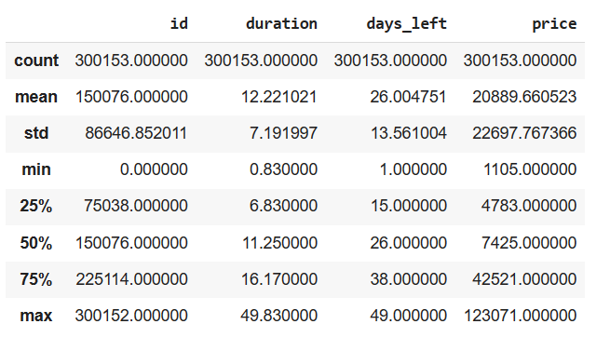

Figure 4.1: Evaluation Parameters

Sr. No. | Column | Non-Null Count | Dtype
0 | Id | 3100 non-null | int64
1 | Airline | 3100 non-null | object
2 | Flight | 3100 non-null | object
3 | source_city | 3100 non-null | object
4 | departure_time | 3100 non-null | object
5 | Stops | 3100 non-null | Object
6 | arrival_time | 3100 non-null | object
7 | destination_city | 3100 non-null | Object
8 | Class | 3100 non-null | object
9 | Duration | 3100 non-null | float64
10 | days_left | 3100 non-null | Int64
11 | Price | 3100 non-null | Int64

Table 4.1: Evaluation Parameters and Concluding Remarks

Interpretation: Figure 4.1 and table 4.1 give an overview of various evaluation parameters which can be used for analysis of behavior; it is observed that, the different evaluation parameters have same concluding remarks. On the basis of this parameters On the basis of this parameters temperature humidity ph rainfall lable going to determine.

Images per class of plant disease:
X axis- names of diseases
Y axis-no. of image per disease
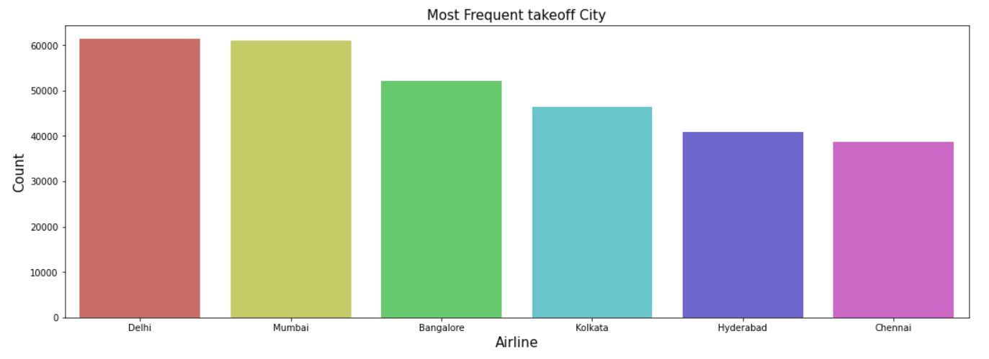
4.2 Most Frequent Takeoff City

Interpretation: Figure 4.2 give an overview of various evaluation parameters which can be used for analysis of behavior; it is observed that, the different evaluation parameters have same concluding remarks. X axis- names of diseases Y axis-no. of image per disease

Validation accuracy for plant disease detection:

X – epoch
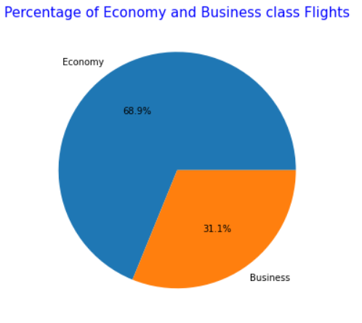
y- accuracy

4.3 Percentage of Economy and Business Class Flight

Interpretation: Figure 4.3 give an overview of various evaluation parameters which can be used for analysis of behavior; it is observed that, the different evaluation parameters have same concluding remarks. X – epoch y- accuracy

Use Case:
Flight detection Use Case

Figure 4.4 Flight detection Use Case

Flight recommendation module

Figure 4.5 Flight recommendation module

  - Chapter Summary
This chapter deals with understanding of flight ticket buying system using Drive type and Number of seats, Acceleration available on. To achieve this goal researcher has first carried out comparative performance analysis of big data technologies. has proposed Pig Data Analytics If the method is applied on a pandas series object, then the method returns a scalar value which is the mean value of all the observations in the dataframe. Machine Learning Algorithms in Chapter 5.

- REFERENCES
- chrome-extension://efaidnbmnnnibpcajpcglclefindmkaj/http://shodh.inflibnet.ac.in:8080/jspui/bitstream/123456789/7328/3/03_literature%20review.pdf
- https://www.researchgate.net/publication/340594772_CROP_YIELD_PREDICTION_USING_MACHINE_LEARNING
- W. Groves and M. Gini, An agent for optimizing airline ticket purchasing, 12th International Conference on Autonomous Agents and Multiagent Systems (AAMAS 2013), St. Paul, MN, May 06 – 10, 2013 , pp. 1341-1342.

- T. Janssen, A linear quantile mixed regression model for prediction of airline ticket prices, Bachelor Thesis, Radboud University, 2014.

Chapter 6
Machine LearningAlgorithm Used

  - Introduction
The problem is identified through the study of literature reviewed in chapter 2 and based on the secondary data collected predictive analytics is designed and implemented in chapter 5. This chapter presents experimental findings of the research and suggestions given. The present study has been carried out in various stages to analyze from the India and Drive Type and no of Seats an effective solution to the Fight Price Analysis & Prediction Model using machine learning algorithms.
  - Experimental Findings
To serve the purpose we have carried out some experiments. Experimental findings are listed in below categories.

    - Selection of Big Data Technologies
To select the suitable technologies researcher has carried out literature review and done performance analysis. Findings are as follows.
- We found Python as a suitable tool along with Data Science Programming model to serve as to clean and process unstructured data in the form of SQL Though. Python is a high level language and requires minimum lines of code.
- We found Spark framework is providing fast execution environment to build a predictive model with Machine Learning algorithms. Its 10 time faster than Hadoop framework.

- We found Decision Tree, Neural Network, and Naive Bayes algorithms suitable for our research for correct predictions and further analysis.
- Data Analytics is not complete without visualization. So we found D3.js for visualize data of crop and fertilizer predication.

    - Linear Regression
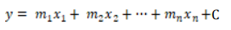
In simple linear regression there's only 1 independent and one dependent feature but as our dataset consists of the many independent features on which the worth may rely on, we are going to be using multiple linear regression which estimates relationship between two or more independent variables and one dependent variable. The multiple linear regression models are represented by:
- Where, y = the predicted value of the dependent variable
- X_{n}= the independent variables
- m= independent variables coefficients
- C= y-intercept x

  - Decision Tree
There are basically of two type’s Decision tree i.e., classification and regression tree where classification is employed for categorical values and regression is employed for continuous values. Decision tree chooses independent variable from dataset as decision nodes for decision making.It divides the entire dataset in several sub-section and when test data is passed to the model the output is determined by checking the section to which the info point belongs to. And to whichever section the info point belongs to the choice tree will give output because the average value of all the information points within the sub-section.

  - Random Forest
Random Forest is an ensemble learning technique where training model uses multiple learning algorithms then combine individual results to urge a final predicted result. Under ensemble learning random forest falls into bagging category where random number of features and records will average value of the expected values if considered because the output of the random forest model.
  - PERFORMANCE METRICS
Performance metrics are statistical models which is able to be accustomed compare the accuracy of the machine learning models trained by different algorithms. The sklearn.metrics module are accustomed implement the functions to live the errors from each model using the regression metrics. Following metrics are accustomed check the error measure of every model.

    - Case Based Suggestions
From the conclusion drawn in the researcher has suggested following case based suggestions as follows,
- No doubt, that no of components affect to the crop and fertilizer prediction because of that data should be clean and analyzed properly for the prediction of crop and fertilizer.
- The prediction model is good enough to predict the crop and fertilizer.
- It is ready for deployment. However, there are still space of improvement in the future. For example Rapid Changes, Power etc.
    - Analytics Based Suggestions
From the conclusion drawn in the researcher has suggested following case based suggestions as follows,
- The study reveals that, to predict data linear regression is the one of the best solution.
- The study suggests that, pig on the top of python is the best choice for extract, transform and load.
- There are the other ways to predict the data using different algorithms
- The present study suggests that, data science is the powerful technique to visualize data in web application format one can use.

  - Contribution Made to The Body of Knowledge and Outcome of Research.
The present study is confined to predict flight price by analyzing given data of Acceleration, efficiency, range. Till date various methods and techniques are used to predict customer behavior. In the present research we tried to develop our won hybrid methodology to predict customer behavior. Our research work is able to
- Help Customer’s to predicate the Which flight is best.
- Help customer to buy Flight Ticket in low price.

  - Scope for Further Study

Research is an unbroken and never-ending process. Improvement and enhancement can be done continuously. It was a very good experience to work on this research topic. Always there is a research exposure, as the new dimensions of research are introduces. By considering such dimensions future work can be carried out to find out hidden exposure.

6.6 Chapter Summary
Present research is about predicting Price using Machine Learning technologies to provide more personalized experience to them. This chapter presents the findings drawn by the researcher from the work done. To reach the conclusions the researcher has carried out various experiments at various stages starting from suitable technology selections to implementation of predictive analytics.

- REFERENCES
- chrome- International Research Journal of Engineering and Technology (IRJET) https://cs229.stanford.edu/proj2015/211_report.pdf
- Design and implementation of ticket price forecasting system https://aip.scitation.org/doi/pdf/10.1063/1.5039083
- EasyChair preprints are intended for rapid dissemination of research results and are integrated with the rest of EasyChair. https://easychair.org/publications/preprint_open/MFTC

BIBLIOGRAPHY
https://google.com
https://stackoverflow.com
https://youtube.com
https://tutorialspoint.com

